**DBMS LAB - Assignment 2**

**Name-** Bhavya Shrivastava**Roll No-** 23052071**Section-** CSE-15

**Q1: Create a new user making “your_name” as user-name and “your_surname” as the password.**

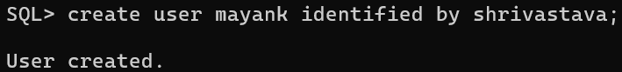

**Q2: Grant all privileges to the newly created user.** 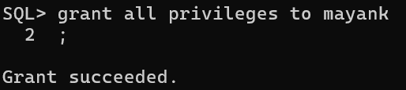

**Q3: connect to the new user.**

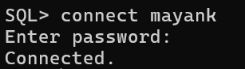

**Q4: Create a table employee with attributes emp_id, f_name , l_name , job_type, salary, commision, dept, and manager_id.**

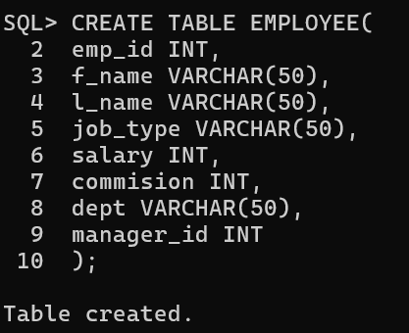

**Q5: Describe the table employee**

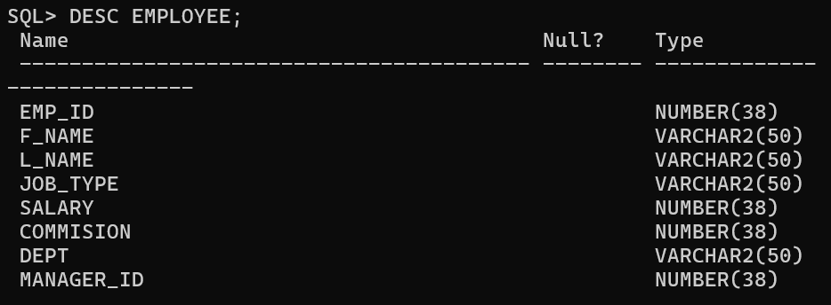

**Q6: Add a new column doj to the employee table.**

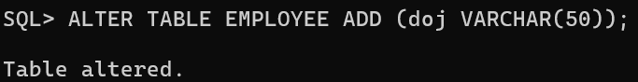

**Q7: Create a new table department with attributes d_name, d_loc, and hod_id.**

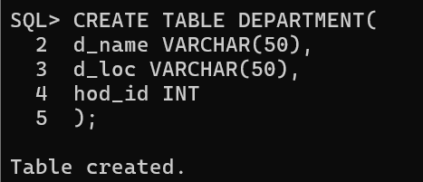

**Q8: Create another table named location with attributes loc_id, city and contact_no.**

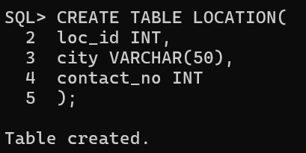

**Q9. Enhance the size of city attribute in location table by 5.**

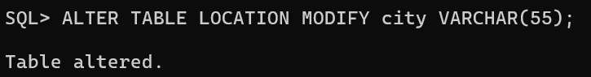

**Q10. Delete the contact_no attribute in the location table.**

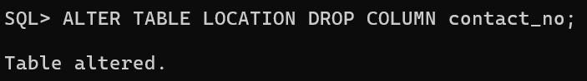

**Q11. Rename the city attribute in the location table to address.**

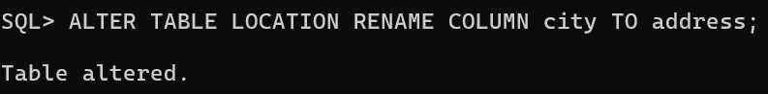

**Q12. Change the name of the table from location to loc.**

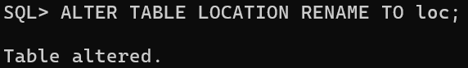

**Q13. Insert the following values into the loc table.**

|  |  |
| --- | --- |
| **LOC_ID** | **ADDRESS** |
| **1** | **kolkata** |
| **2** | **mumbai** |

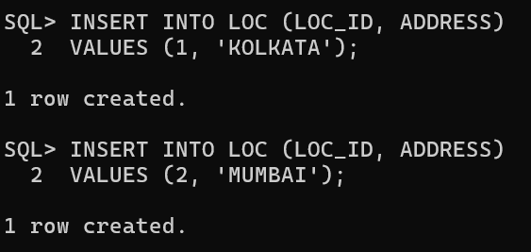

**Q14. Show the values of location table.**

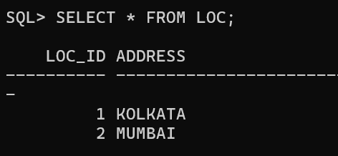

**Q15. Delete all values and spaces consumed by loc table.**

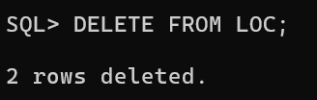

**Q16. Delete the loc table.**

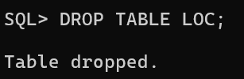

**Q17. Insert the following values into the department table.**

|  |  |  |
| --- | --- | --- |
| **D_Name** | **D_LOC** | **HOD_ID** |
| **sales** | **Kol** | **4** |
| **accounts** | **delhi** | **6** |
| **production** | **kol** | **1** |
| **marketing** | **kol** | **2** |
| **r&d** | **delhi** | **8** |

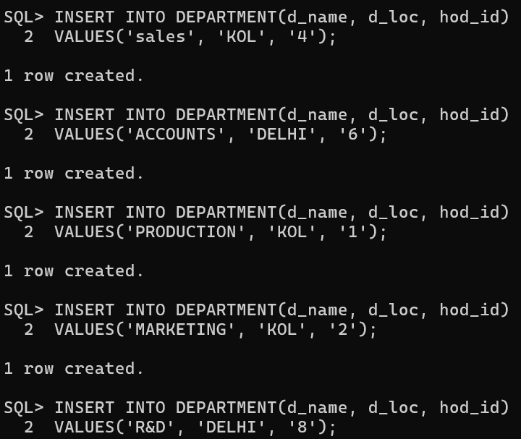

**Q18. Insert the following values into the employee table.**

|  |  |  |  |  |  |  |  |  |
| --- | --- | --- | --- | --- | --- | --- | --- | --- |
| **EMP_ID** | **F_NAME** |  | **L_NAME JOB_TYPE** |  | **SALARY COMMISION** |  | **DEPT MANAGER_ID** | **DOJ** |
| **1** | **arun** | **khan** | **manager** | **90000** |  | **production** |  | **04-JAN-1998** |
| **2** | **barun** |  | **kumar manager** | **80000** |  | **marketing** |  | **09-FEB-1998** |
| **3** | **chitra** | **kapoor** | **engineer** | **60000** |  | **production** | **1** | **08-JAN-1998** |
| **4** | **dheeraj** | **mishra** | **manager** | **75000** |  | **sales** | **2** | **27-DEC-2001** |
| **5** | **emma** | **dutt** | **engineer** | **55000** |  | **production** | **1** | **20-MAR-2002** |
| **6** | **floki** | **dutt** | **accountant** | **70000** |  | **accounts** |  | **16-JUL-2000** |
| **7** | **dheeraj** | **kumar** | **clerk** | **40000** |  | **accounts** | **6** | **01-JUL-2016** |
| **8** | **saul** | **good** | **engineer** | **60000** |  | **r&d** |  | **06-SEP-2014** |
| **9** | **mou** | **bhat** | **clerk** | **30000** |  | **sales** | **4** | **08-MAR-2018** |
| **10** | **sunny** |  | **deol salesman** |  | **20000 10000** | **marketing** | **2** | **31-MAR-01** |
| **11** | **bobby** |  | **deol engineer** | **35000** |  | **r&d** | **8** | **17-OCT-17** |
| **12** | **amir** | **khan** | **salesman** |  | **15000 5000** | **marketing** | **2** | **11-JAN-13** |

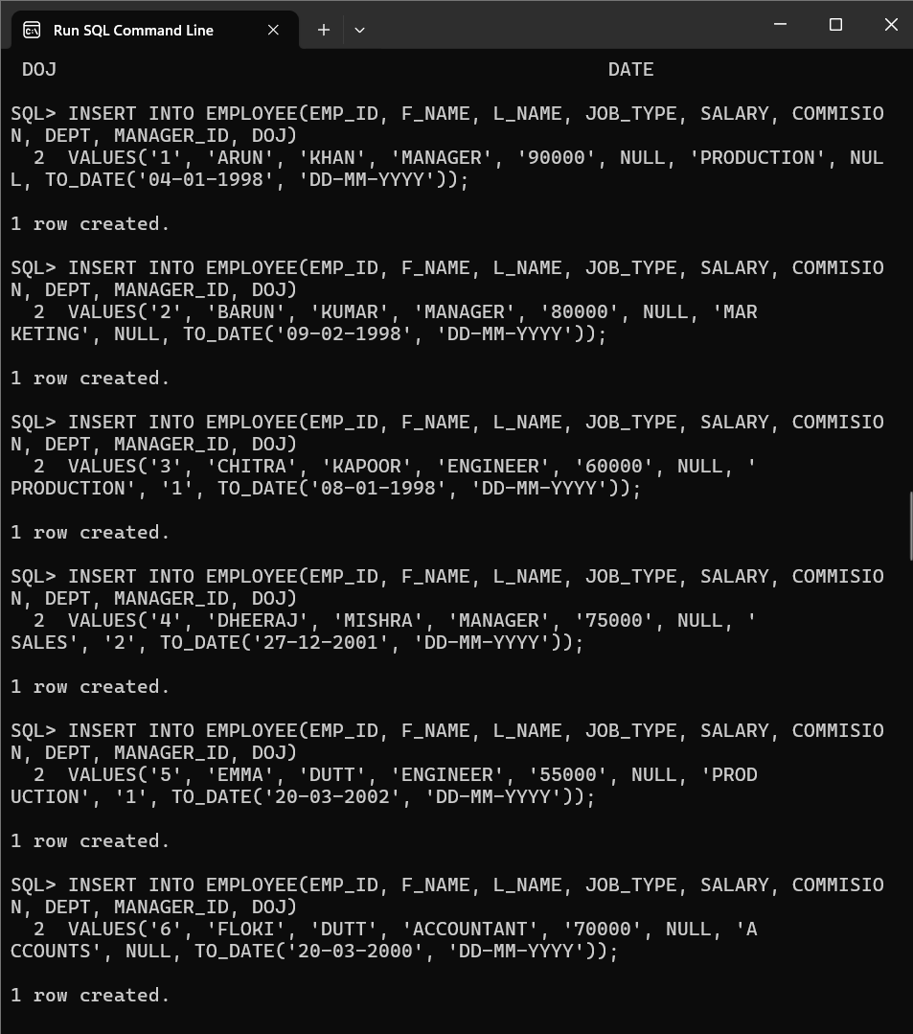

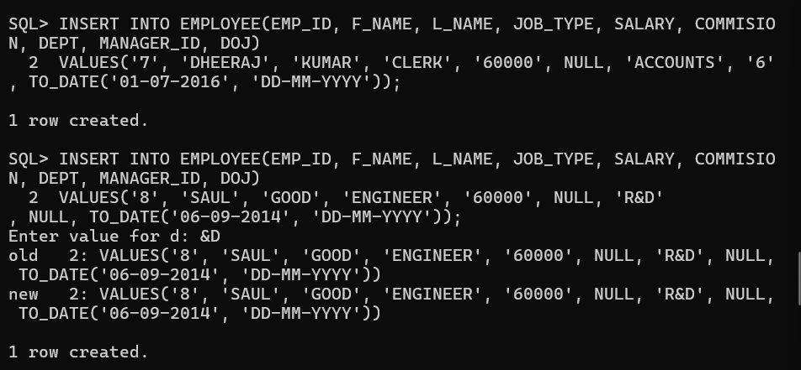

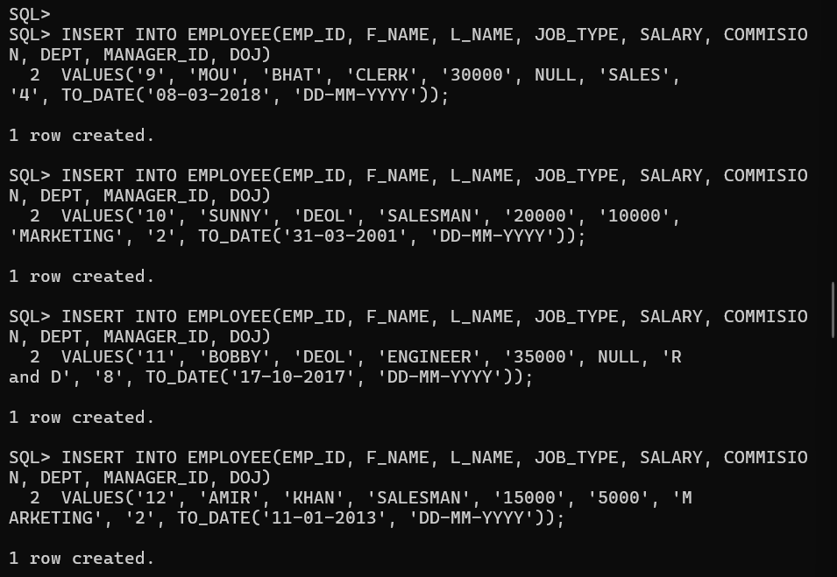

**Q19. Save the database.**

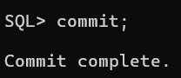

**Q20: Show all the attribute values of the department table.**

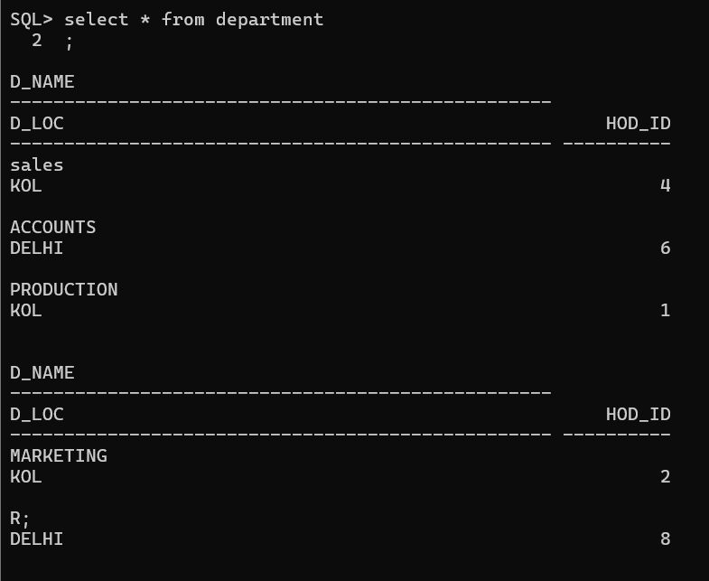

**Q21: Display the department names and their locations.**

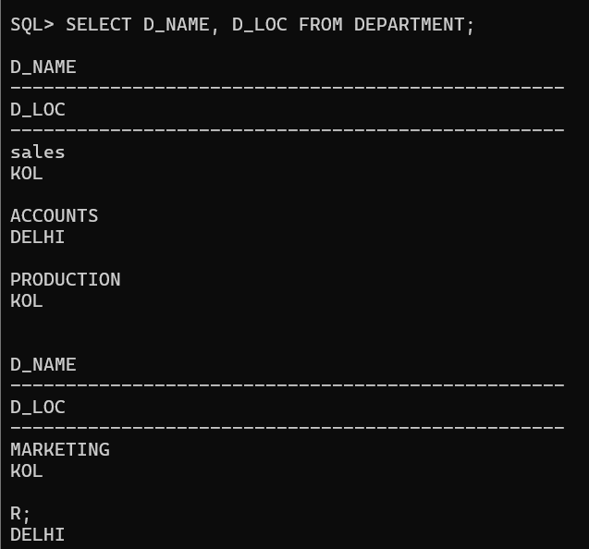

**Q22: Show the employee’s first name, last name, current salary and the salary with a 1000 rupees bonus.**

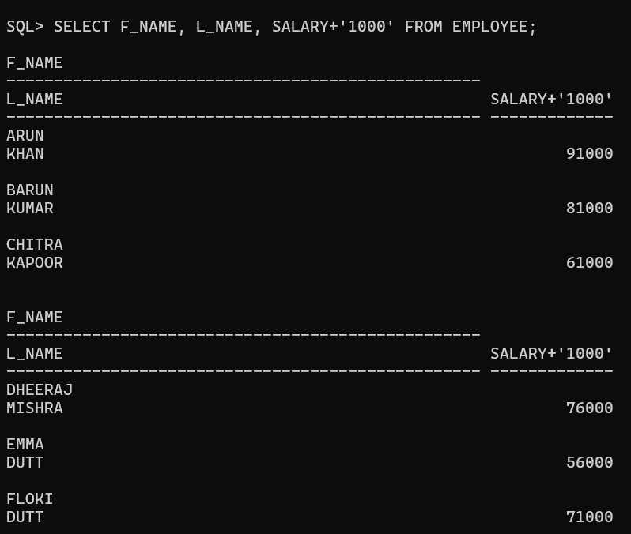

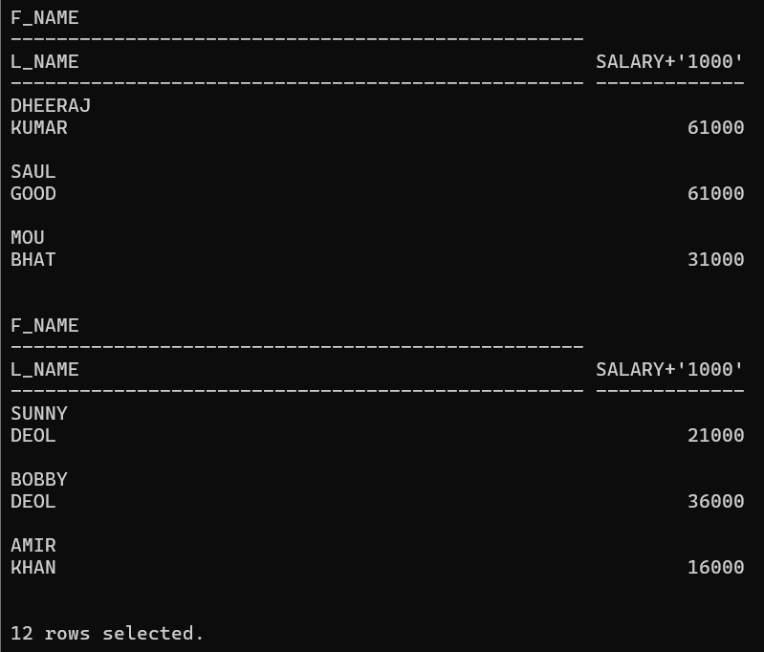

**Q23: Show the employee’s annual salary with a 1000 rupees yearly bonus and the annual salary witha100 rupees monthly bonus.**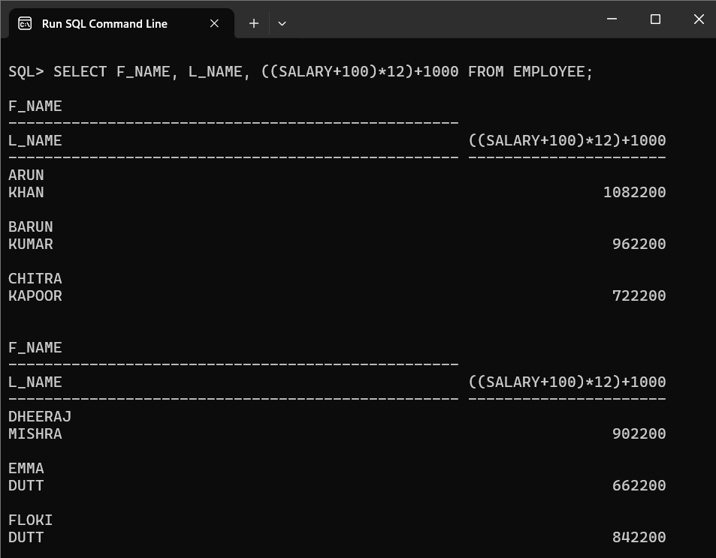

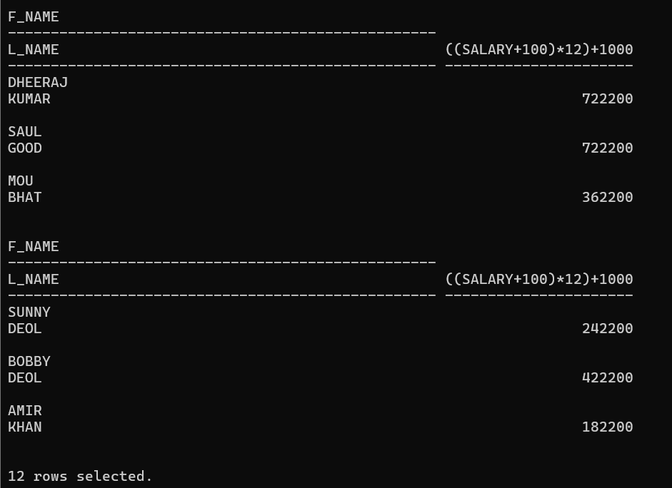

**Q24: Show f_name as Name and annual salary as ANNSAL from the employee table.**

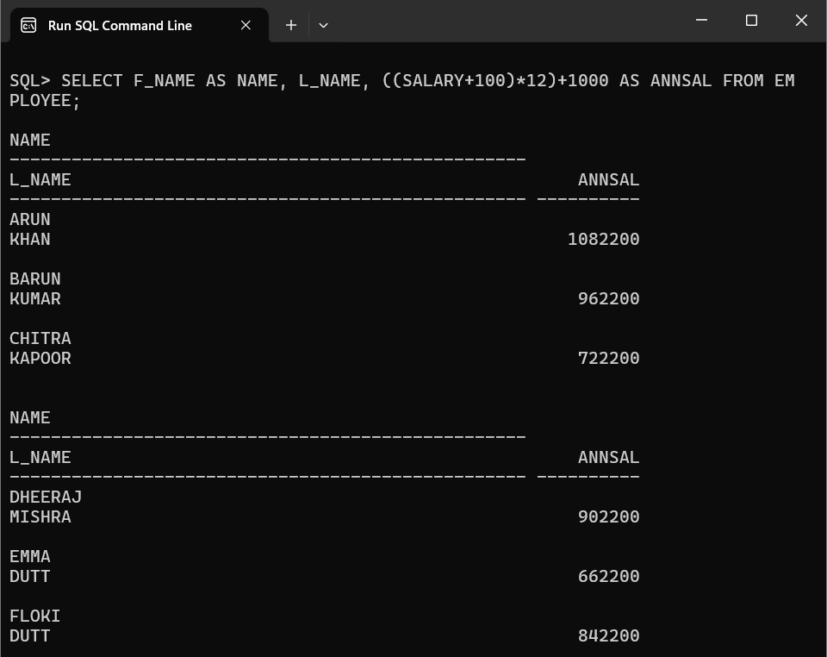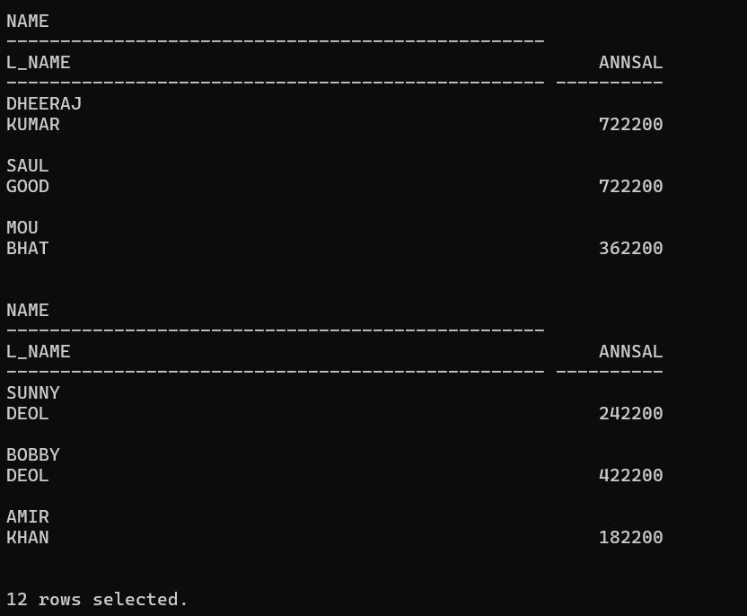

**Q25: Show the L_name as SurName and 100 rupees incremented salary as NewSal fromthe employeetable.**

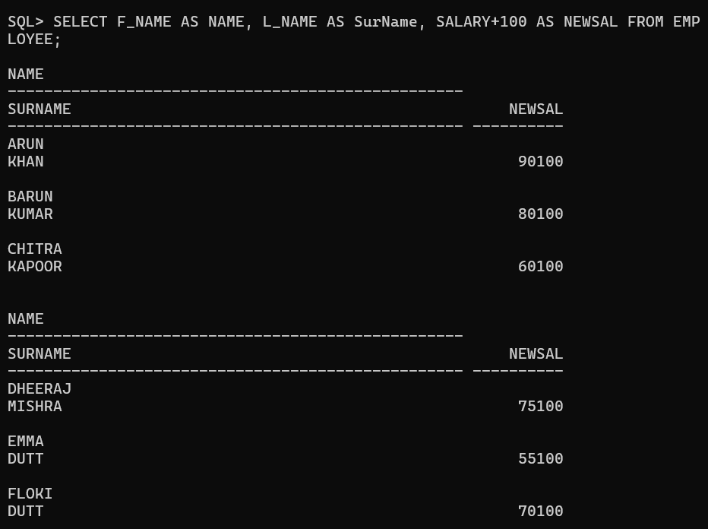

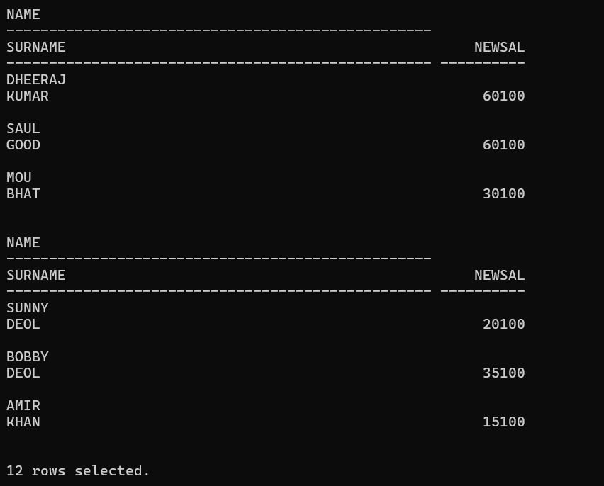

**Q26: Display the employees f_name and l_name joined together using the concatenation operator.**

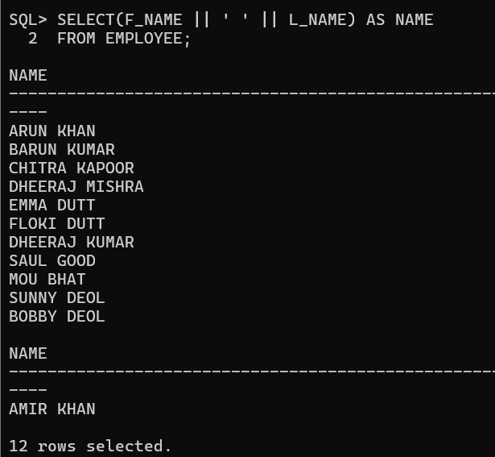

**Q27: Show the f_name, l_name and job_type as Employees.**

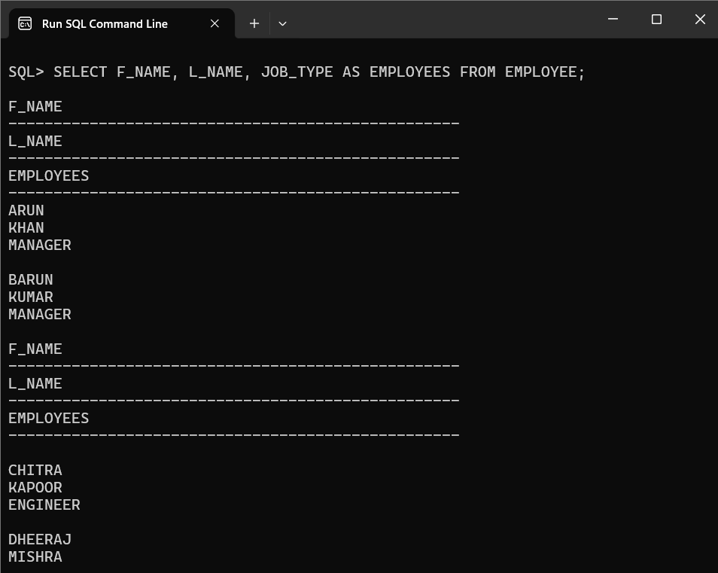

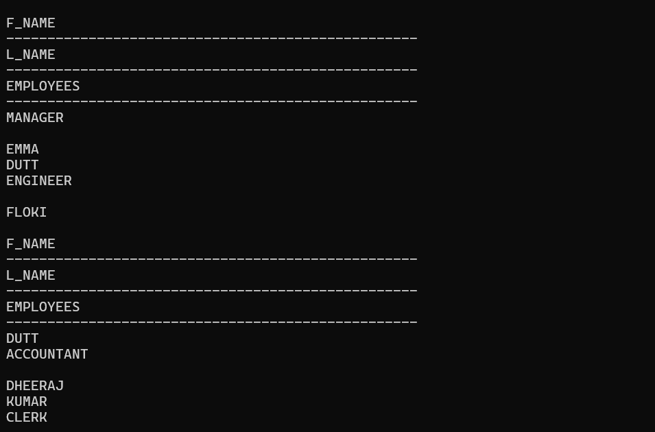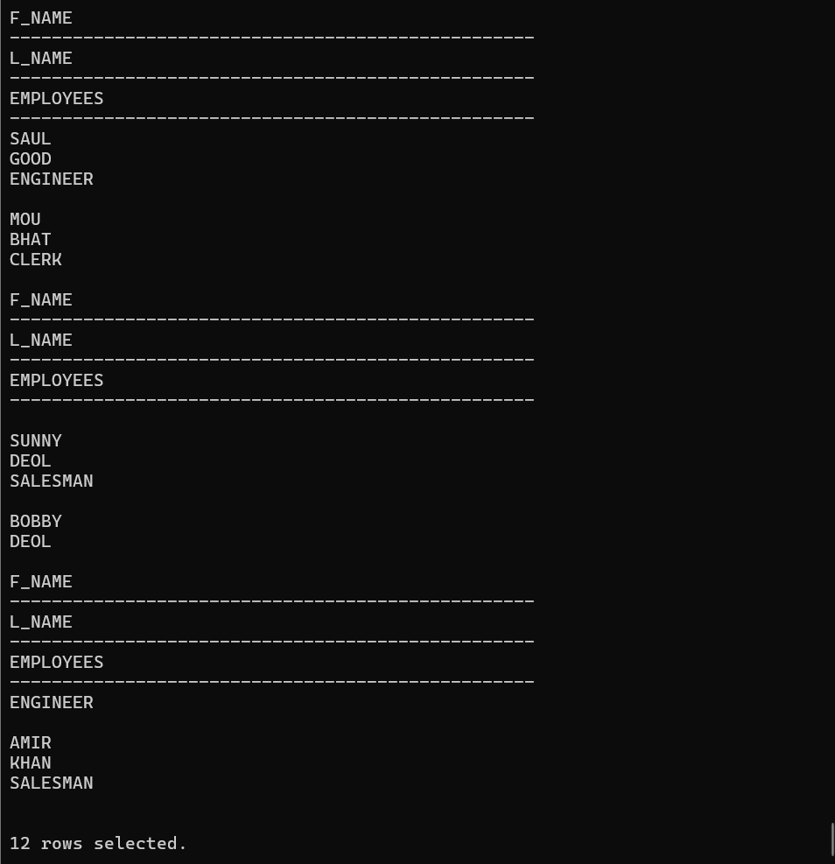

**Q28: Show the employee details in the following fassion:**

**Employees Details**

**---------------------------------------------------------**

**arun khan is a manager**

**barun kumar is a manager**

**……..**

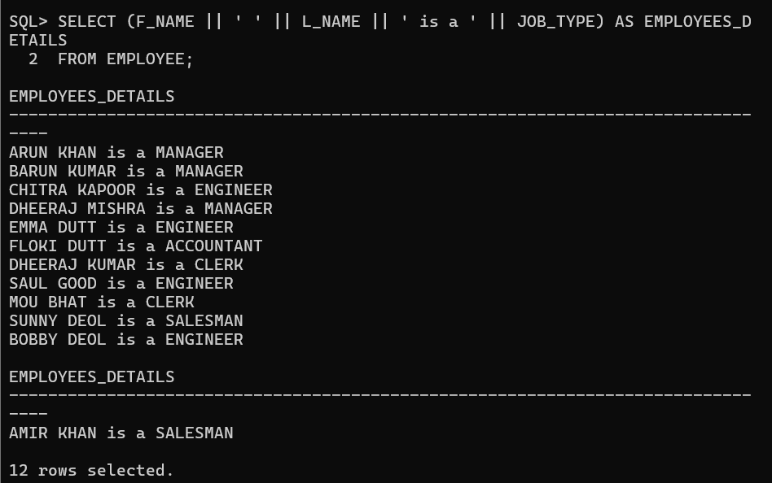

**Q29: Show the monthly salary details in the following fassion:**

**Monthly Salary Details**

**--------------------------------------------------------------------------------**

**arun's monthly salary is 90000**

**………**

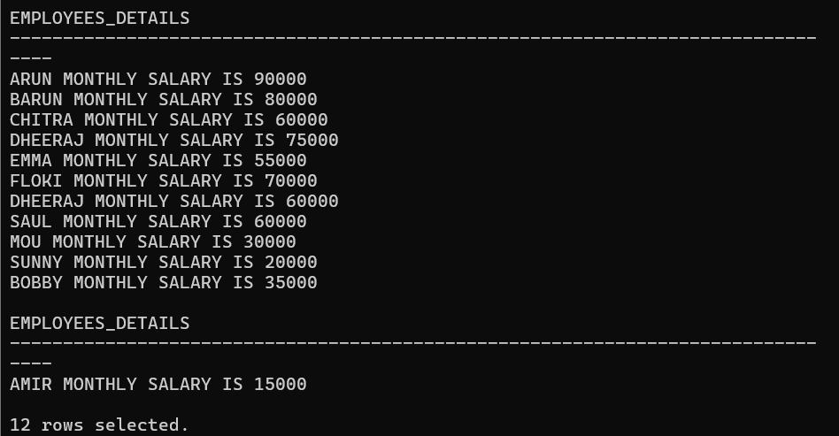

**Q30: Show the department names from the employee table.**

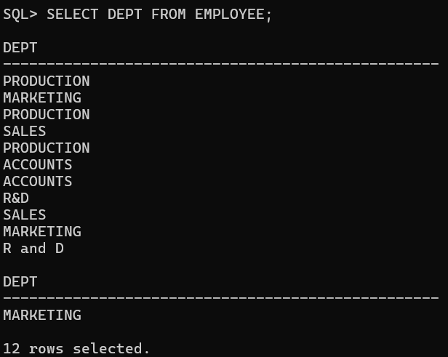

**Q31: Show the distinct department names from the employee table.**

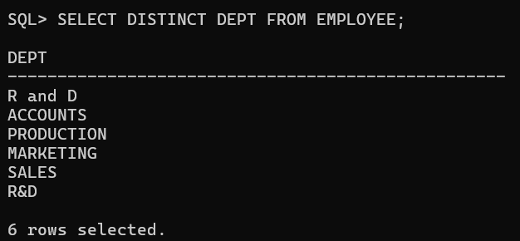

**Q32: Show the employees earning more than 50000.**

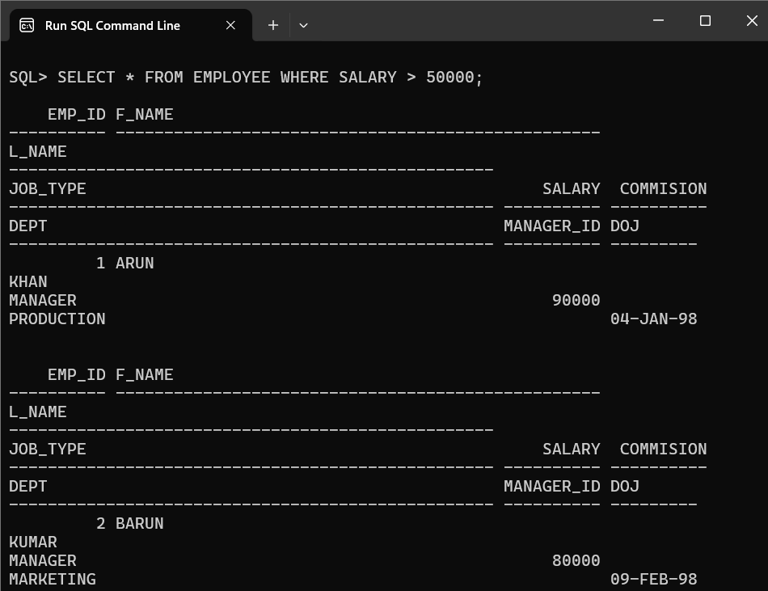

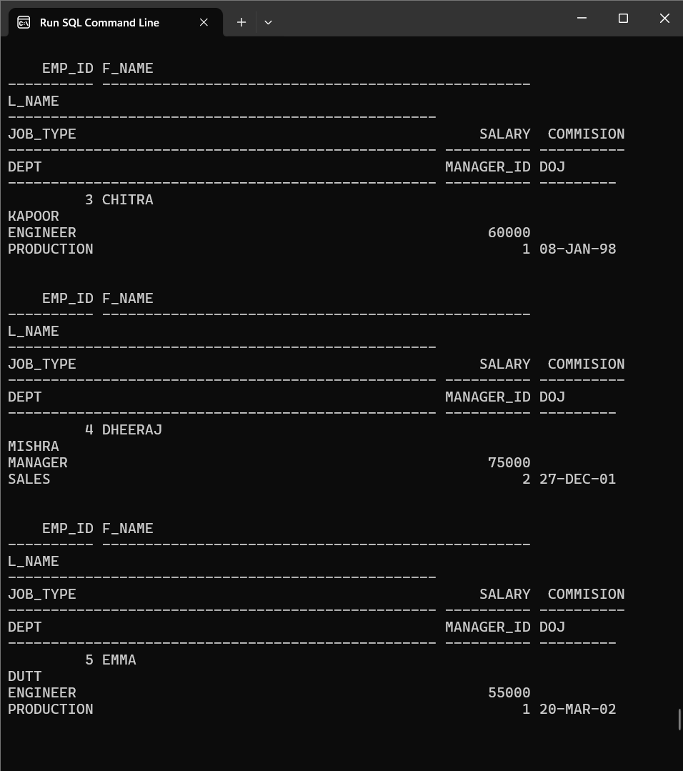

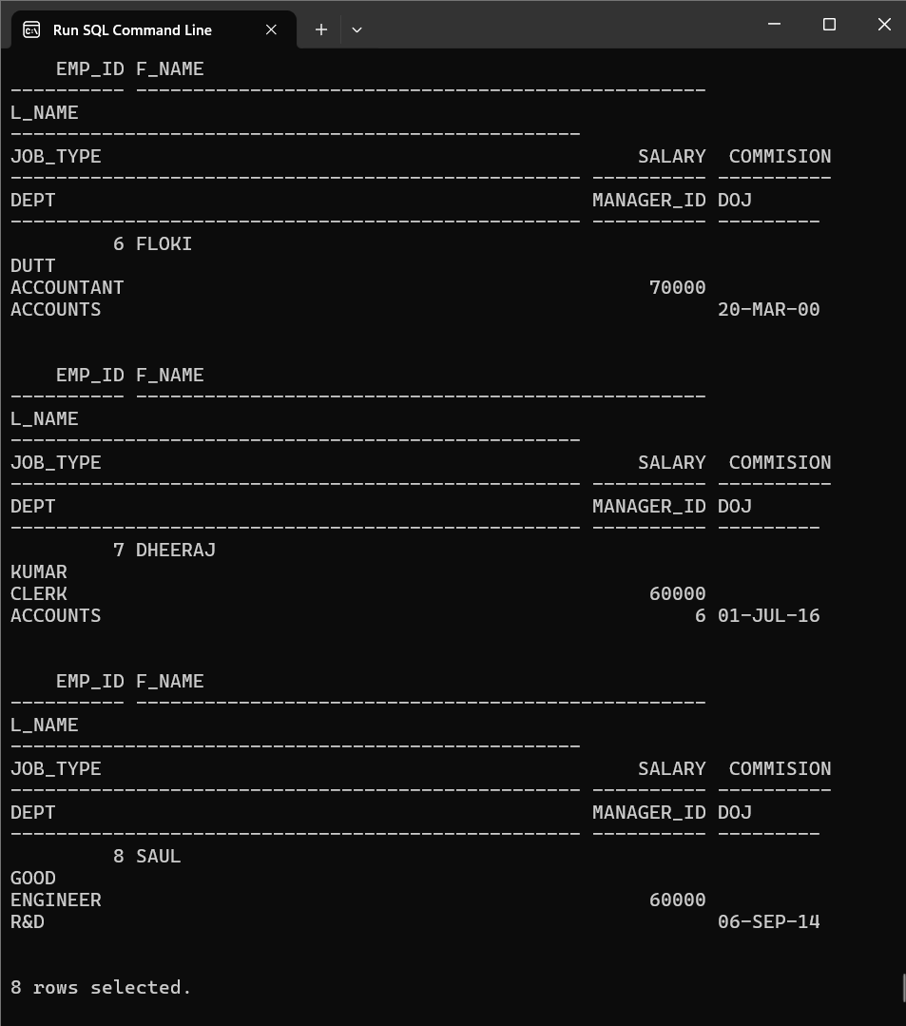

**Q33. Show the employee’s id’s who are not working under manager id-1.**

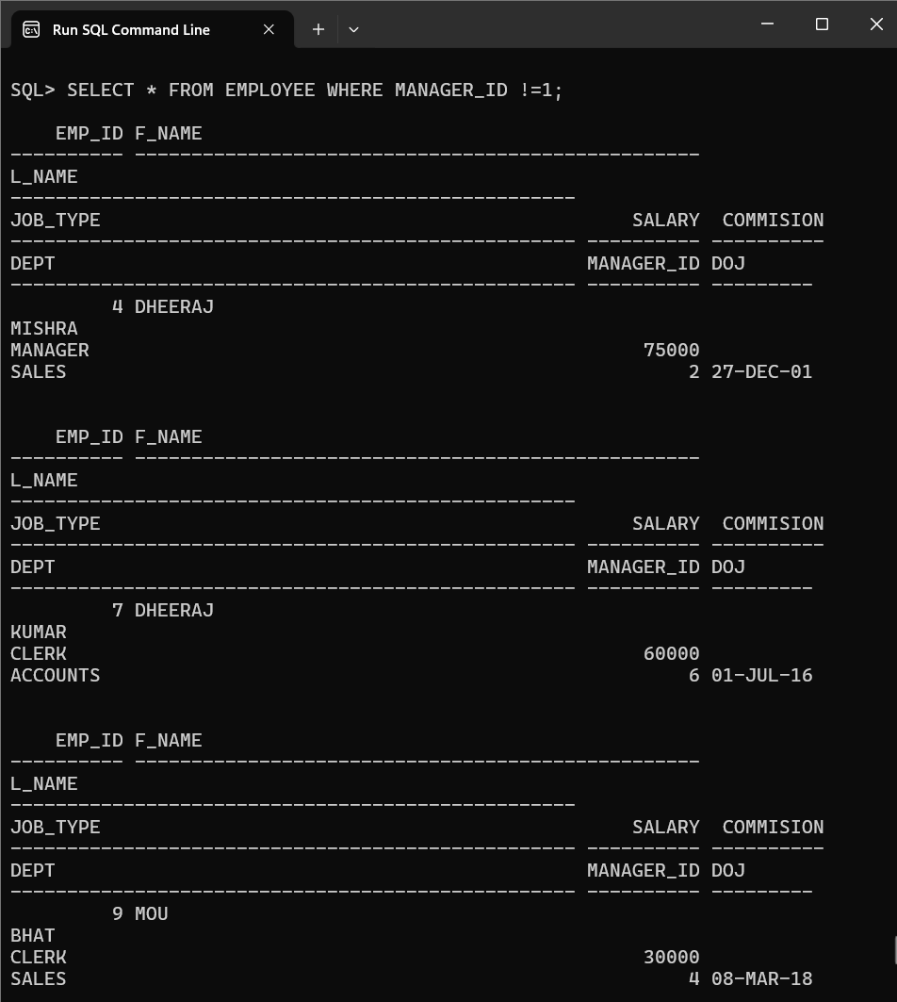

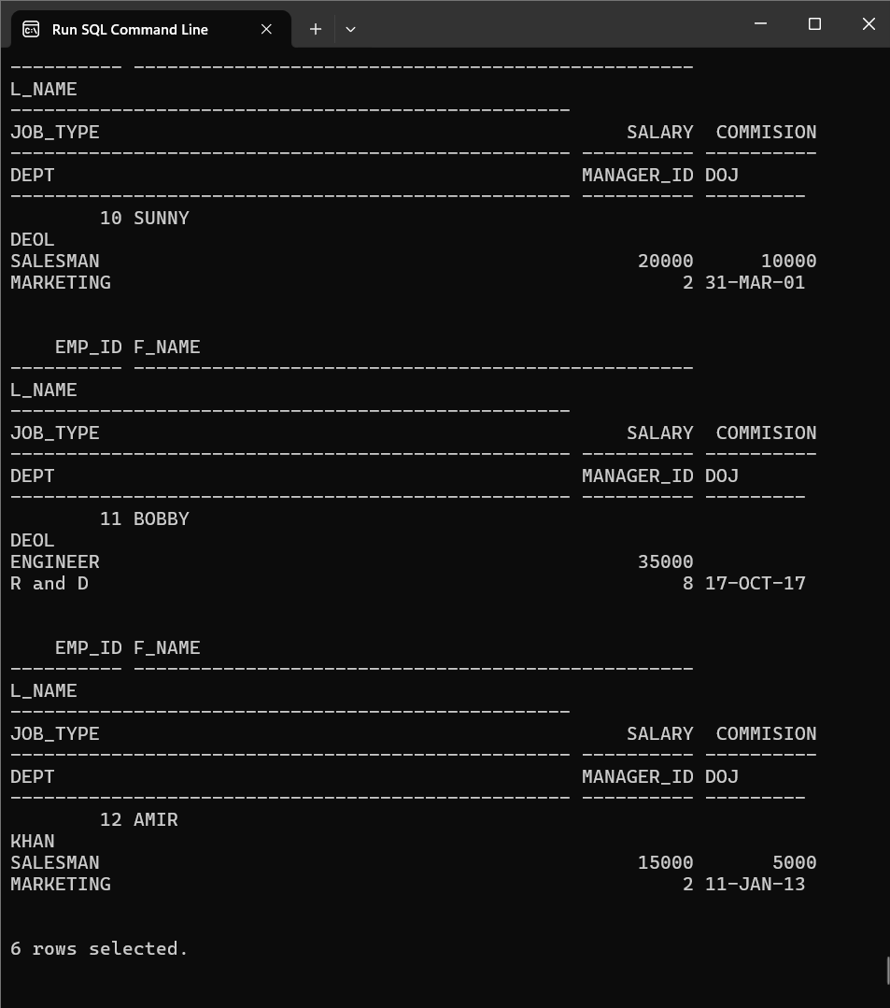

**Q34: Show the employee’s names and salaries whose salary ranges between 40000 to 70000.**

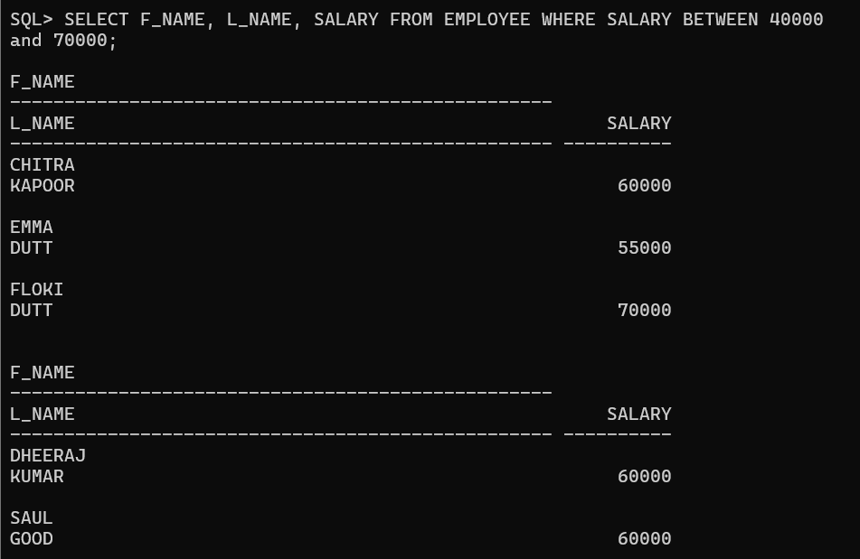

**Q35: Show the employees who work for manager id 1 or 6 or 8.**

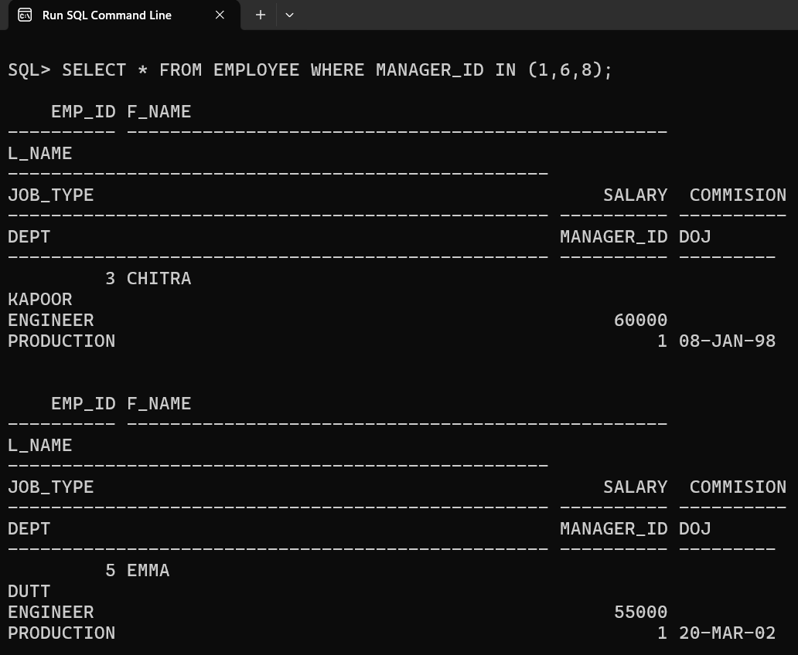

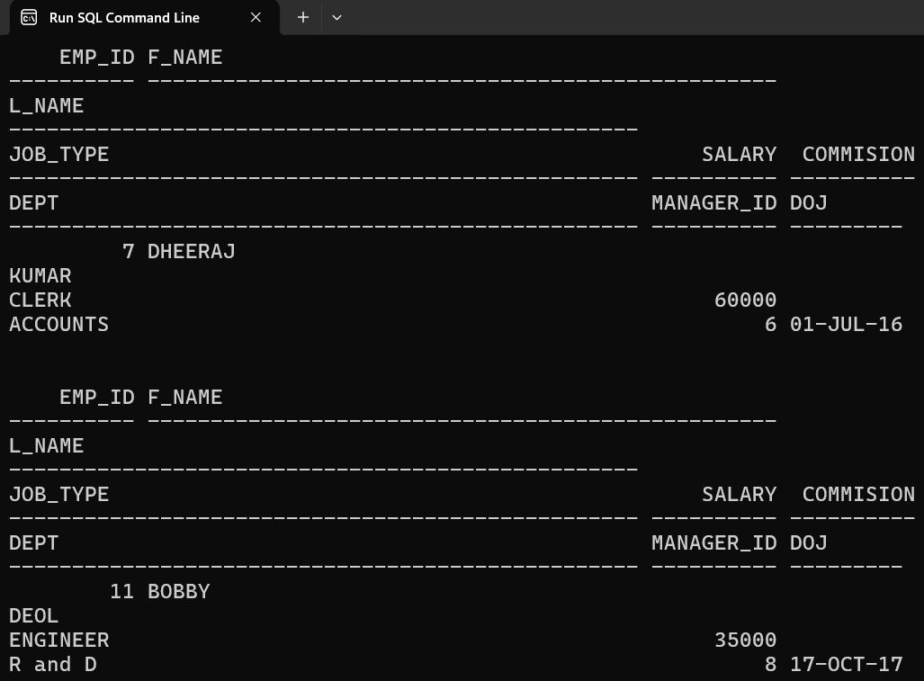

**Q36: Select the first names and salaries of those employee whose last name is khan.**

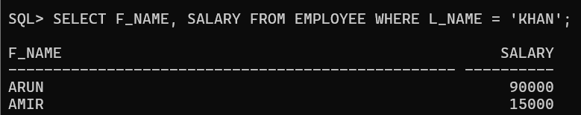

**Q37: Select the first names and salaries of those employee whose last name starts with k.**

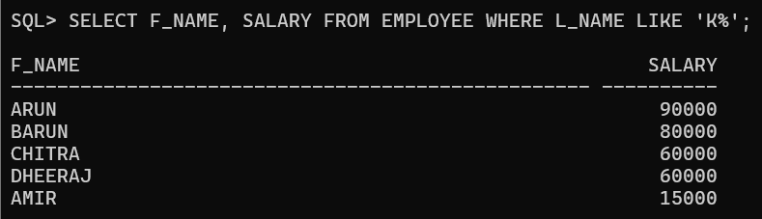

**Q38: Select the first name, last name and salary of those employee whose last name starts with k andends with r.**

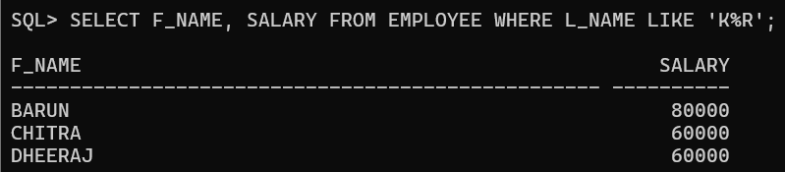

**Q39: Select the employees whose 3rd letter of their last name is o.**

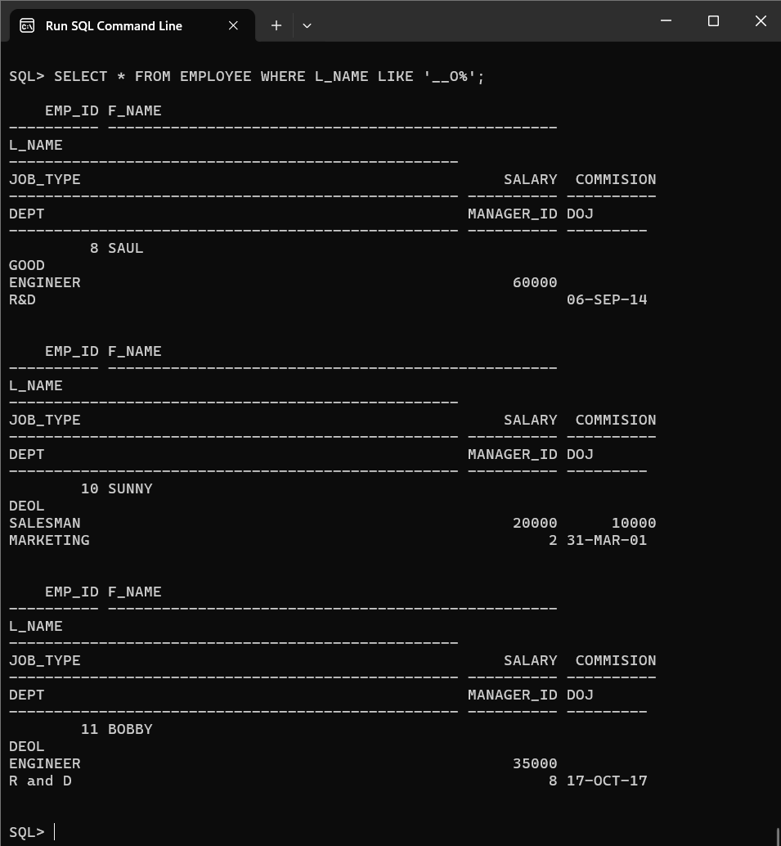

**Q40: Select the employees who are not working under any manager.**

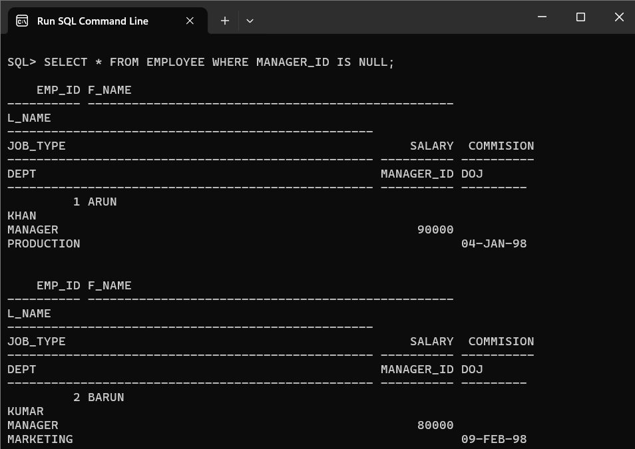

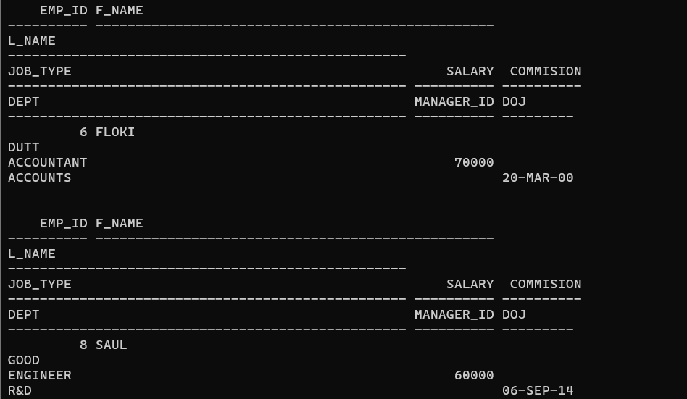

**Q41: Select the employees who work as engineers with salary greater than 50000.**

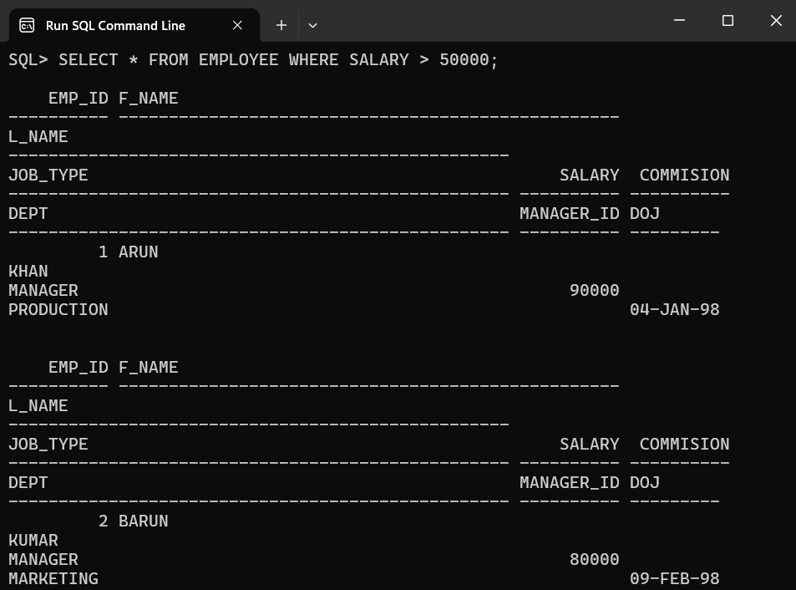

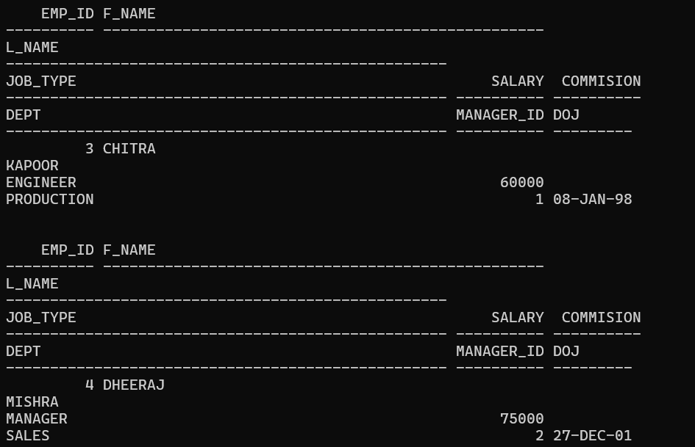

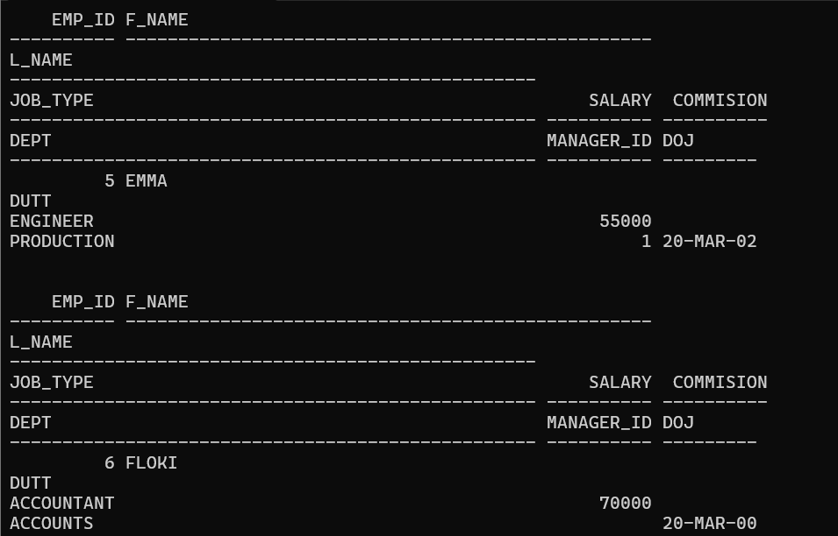

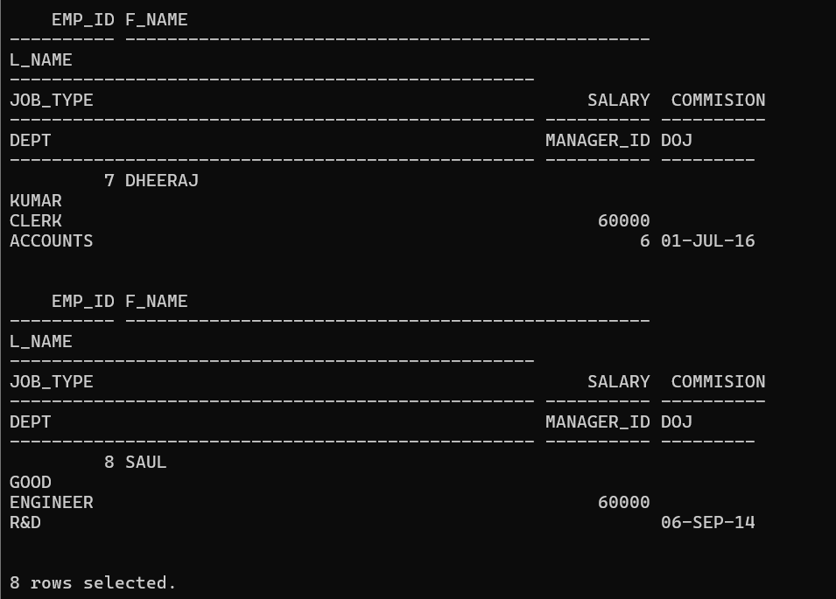

**Q42: Select the employees who work in the production department or earns more than 60000.**

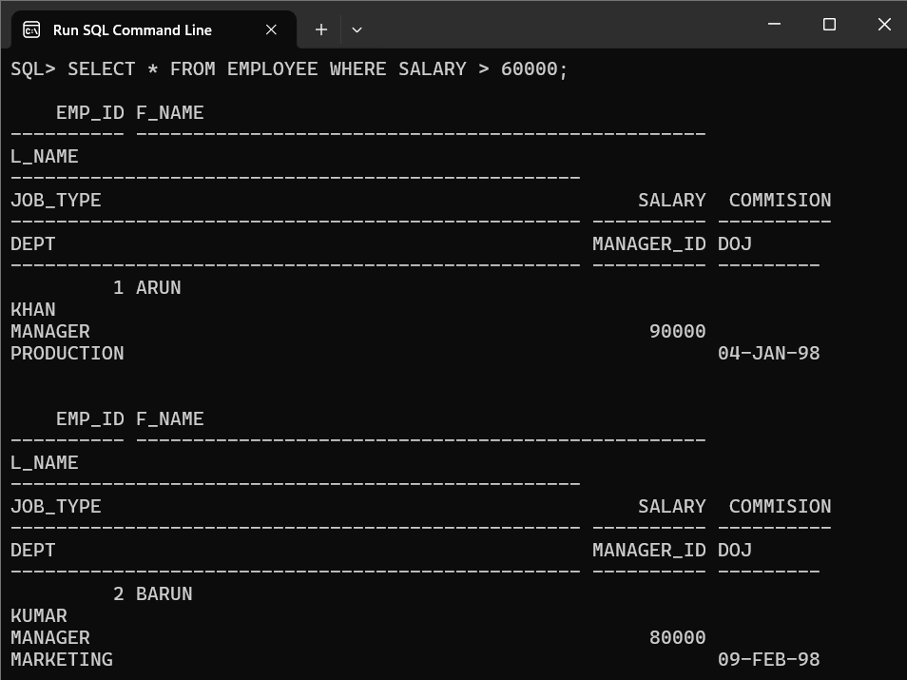

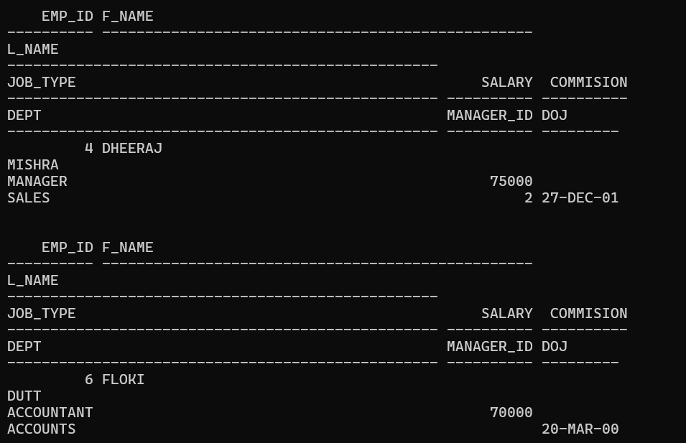

**Q43: Select those employees who are not managers or engineers or clerks.**

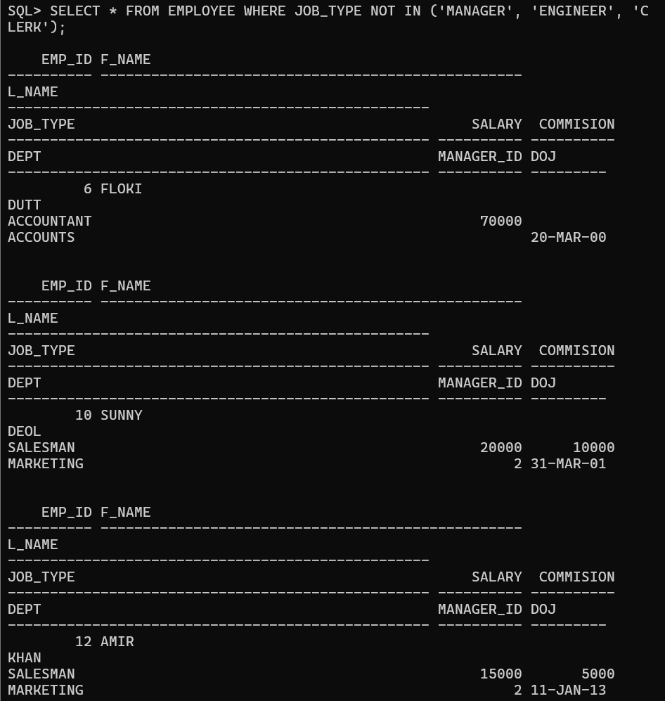

**Q44: Select the employees who earns more than 49000 or less than 29000.**

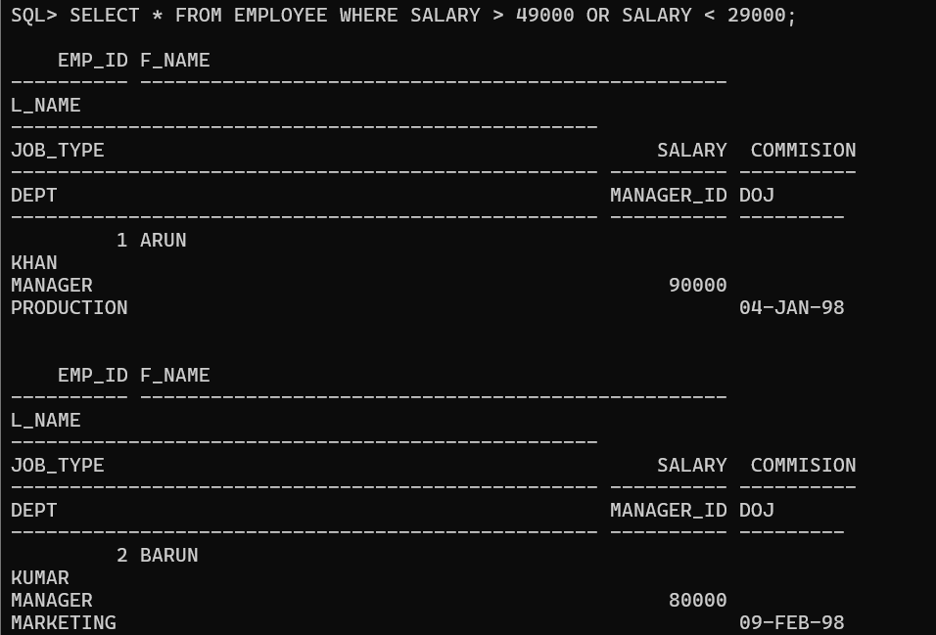

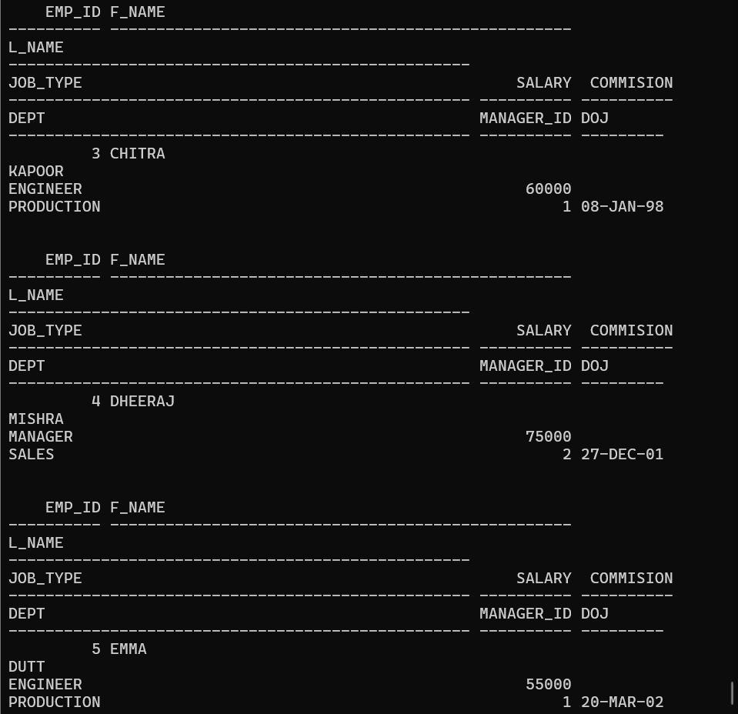

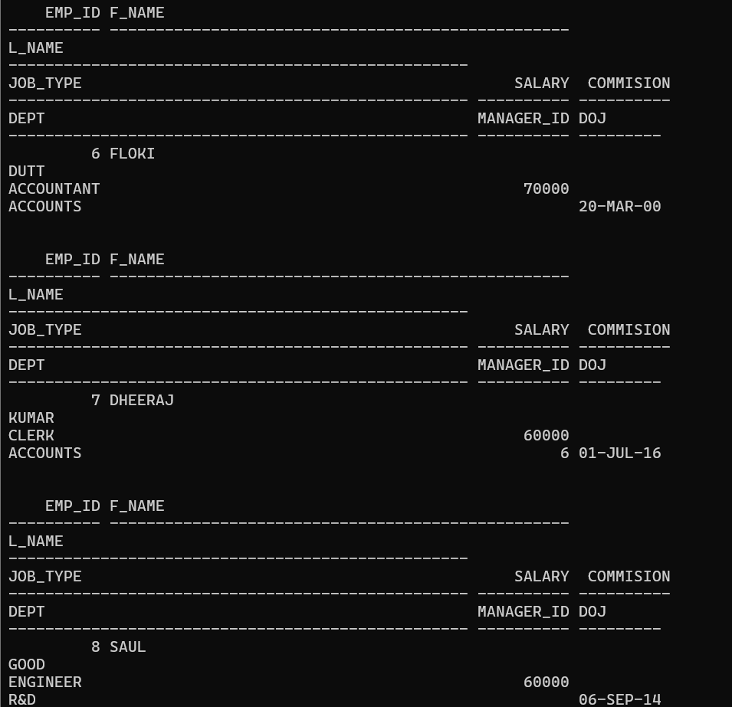

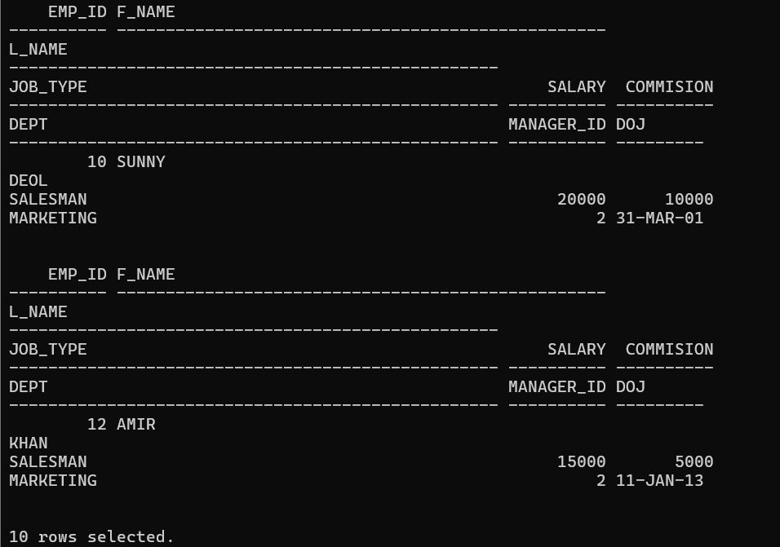

**Q45. Select the employees who don’t have an ‘o’ as the 2nd last letter of their last name.**

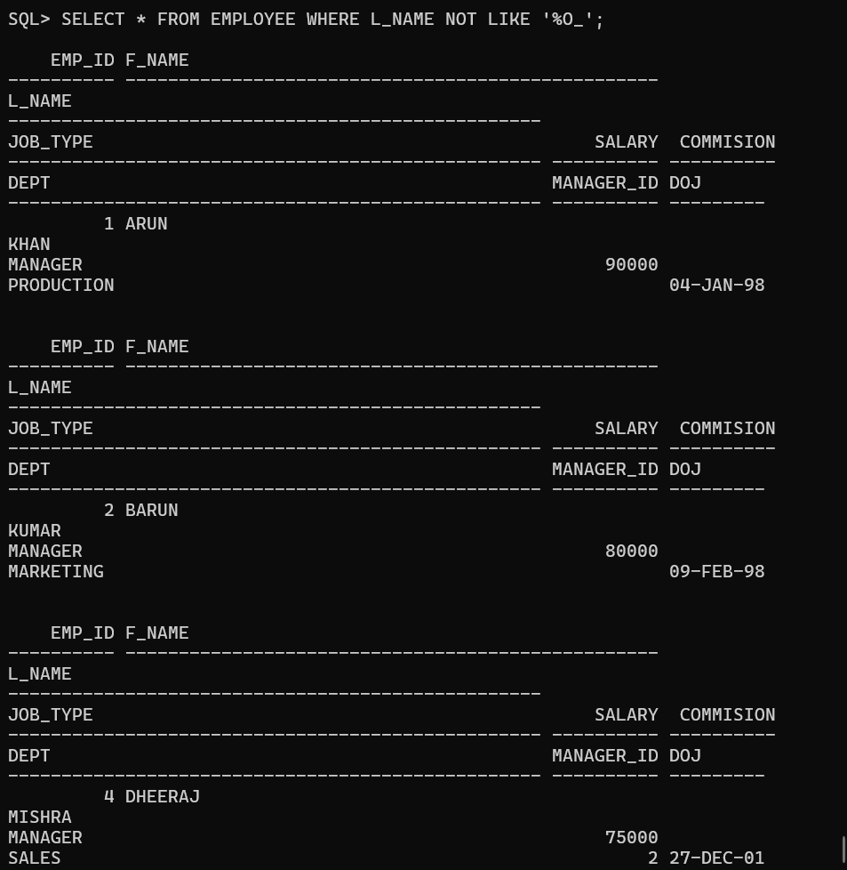

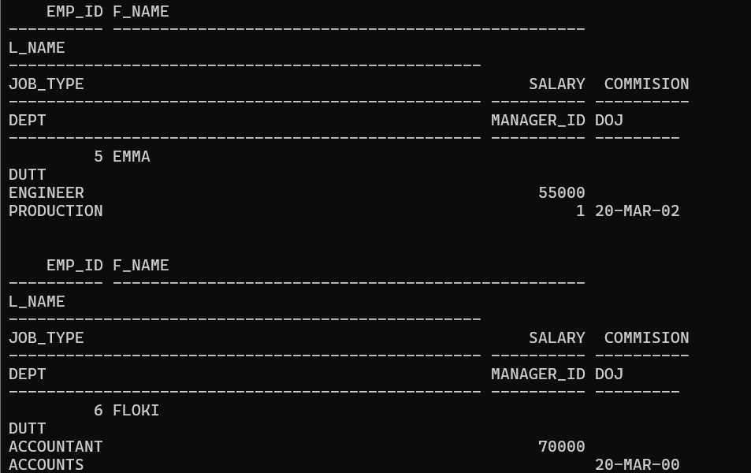

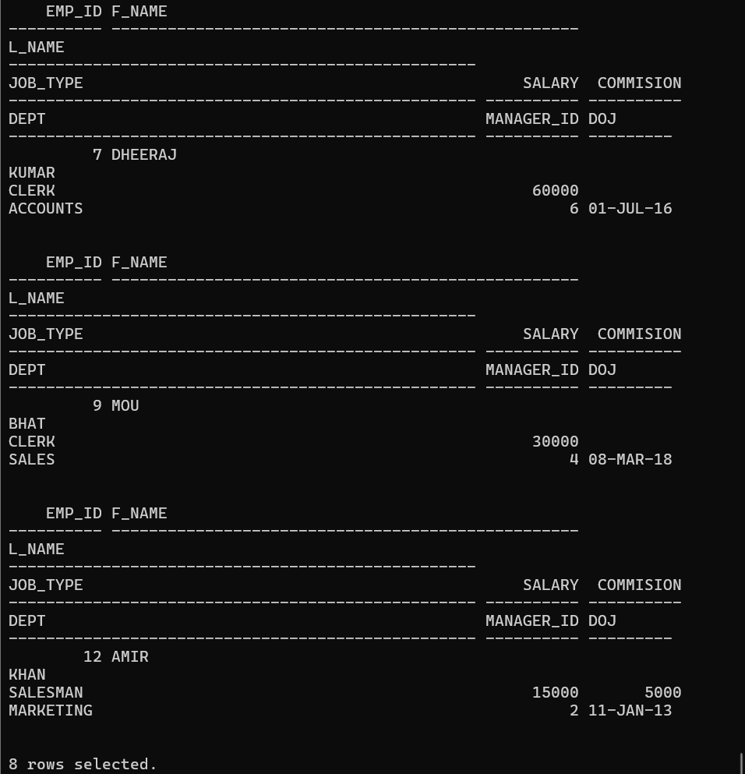

**Q46. Select the employees who get commission.**

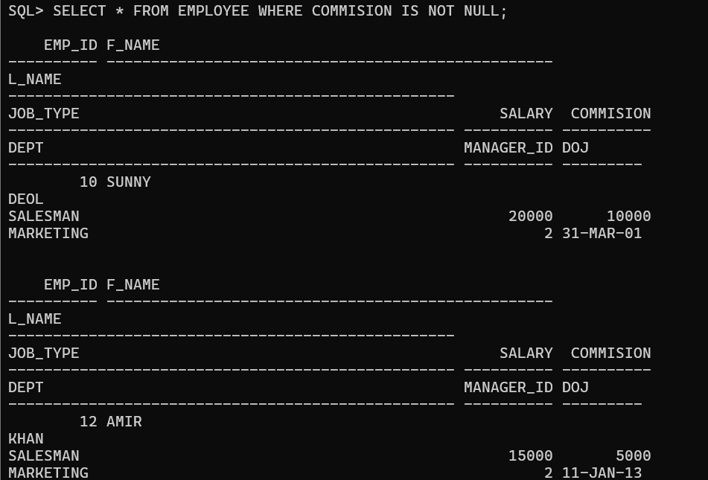

**Q47. WAQ to display the current date.**

**Q48. Show the total experience in weeks for all the employees.**

**Q49. Find the employees working under employee_id 2.**

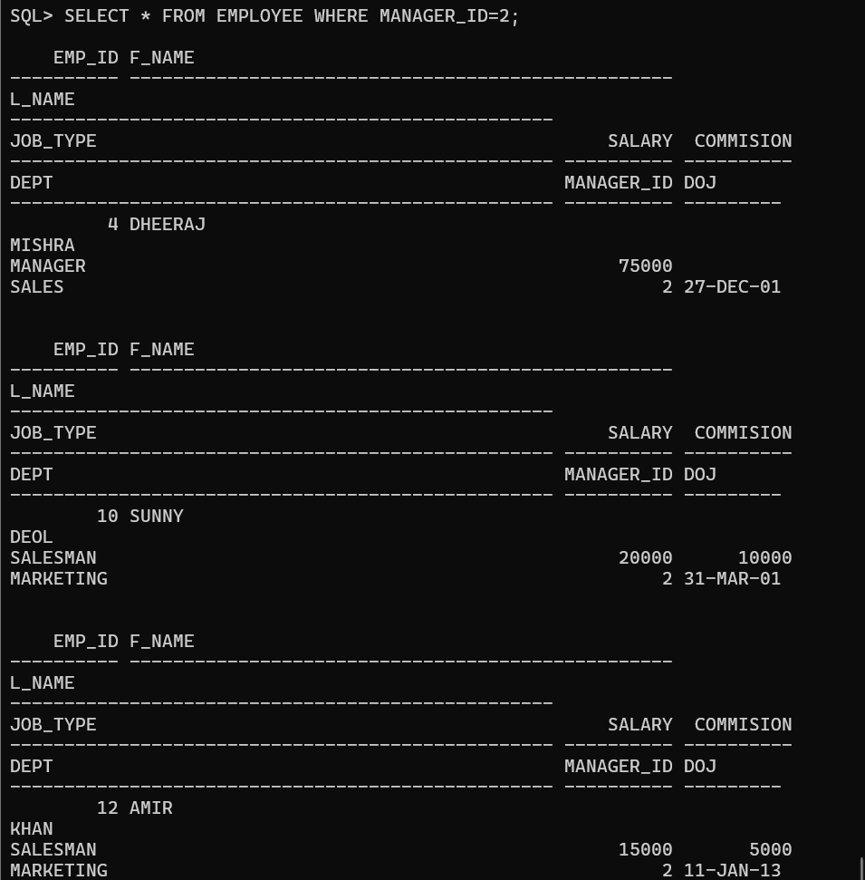

**Q50. Delete the employees from sales department if they are not working as managers.**



**Q51. Insert the following two rows in the employee table without inserting any value in the department field.**

**EMP_ID F_NAME L_NAME JOB_TYPE SALARY COMMISION D_NAME MANAGER_IDDOJ 13 anand patil engineer 28000 2000 1 31-JAN-1714 anandi patel clerk 12000 500 1 01-APR-17**

**Q52. . Insert the following two rows in the department table.**

**D_NAME D_LOC HOD_ID**

**---------- ---------- ----------**

**Admin Mumbai 5**

**Transport Mumbai 3**

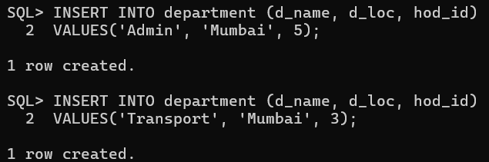

**Q53. Update the employee table. Assign Anand to the admin department.**

**Q54. Update the manager_id from 2 to 1 in the employee table.**



**Q55. Display the employee details in descending order on their salary.**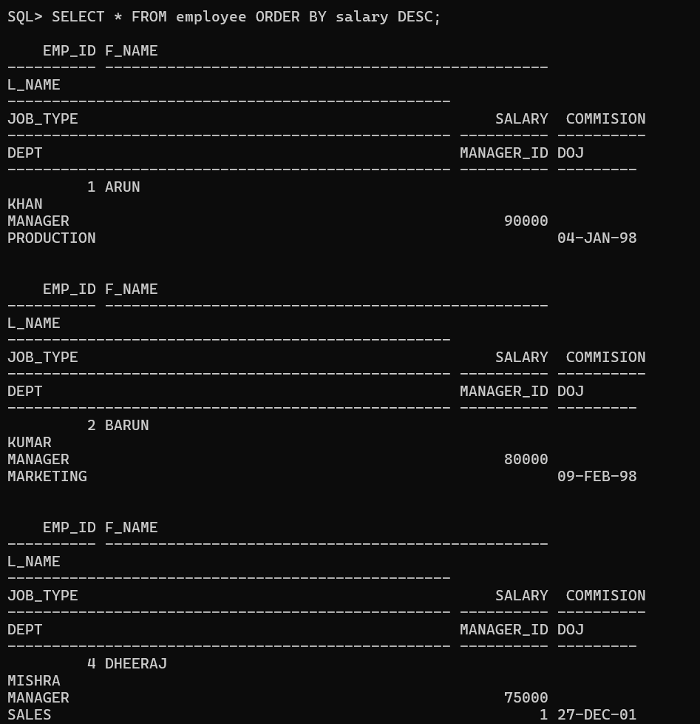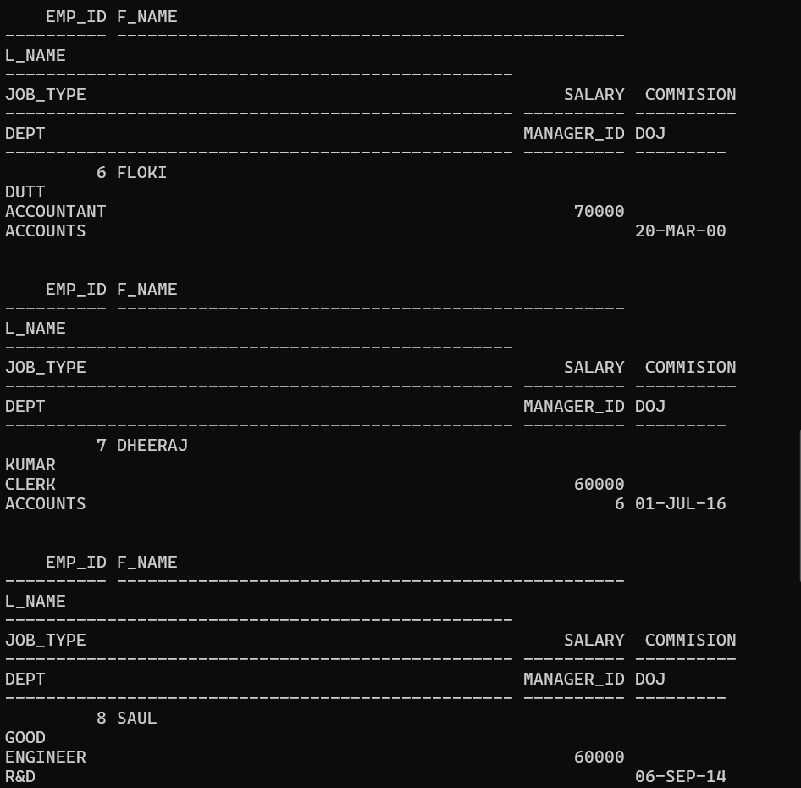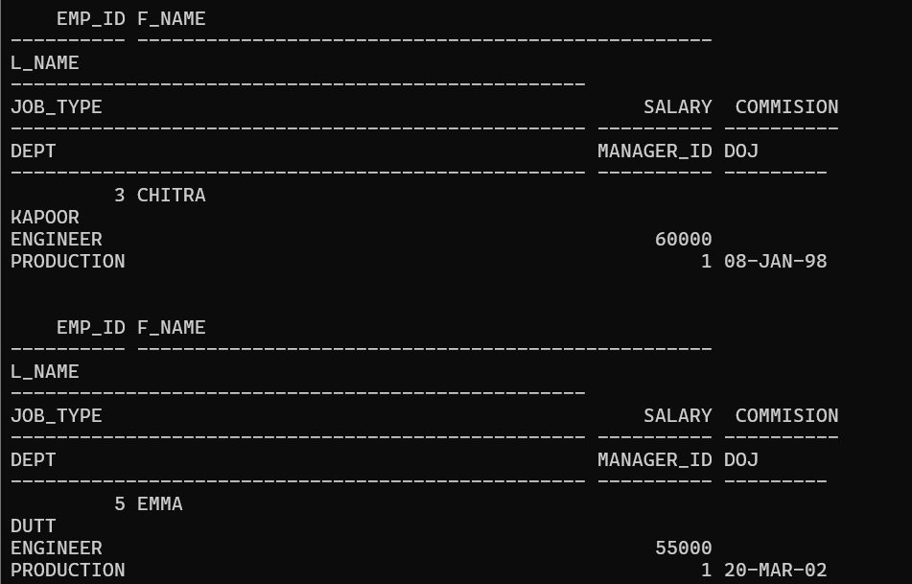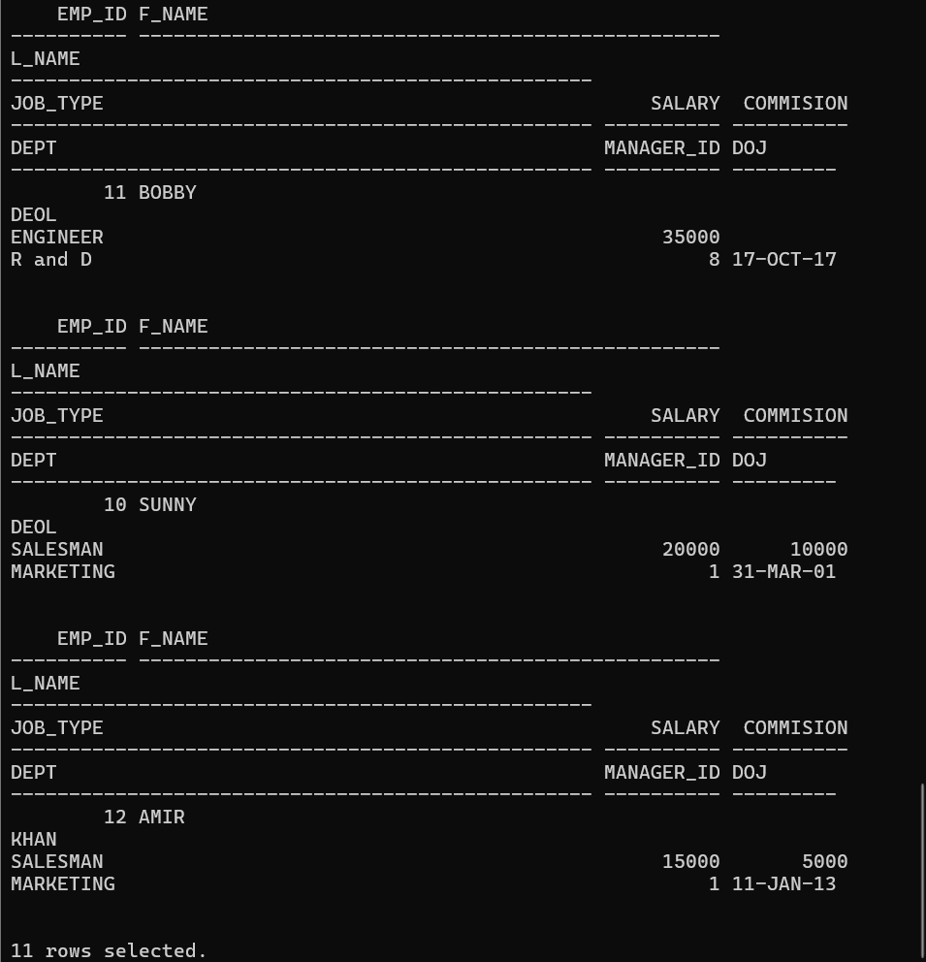

**Q56. Display the employee details in ascending order on their l_name.**

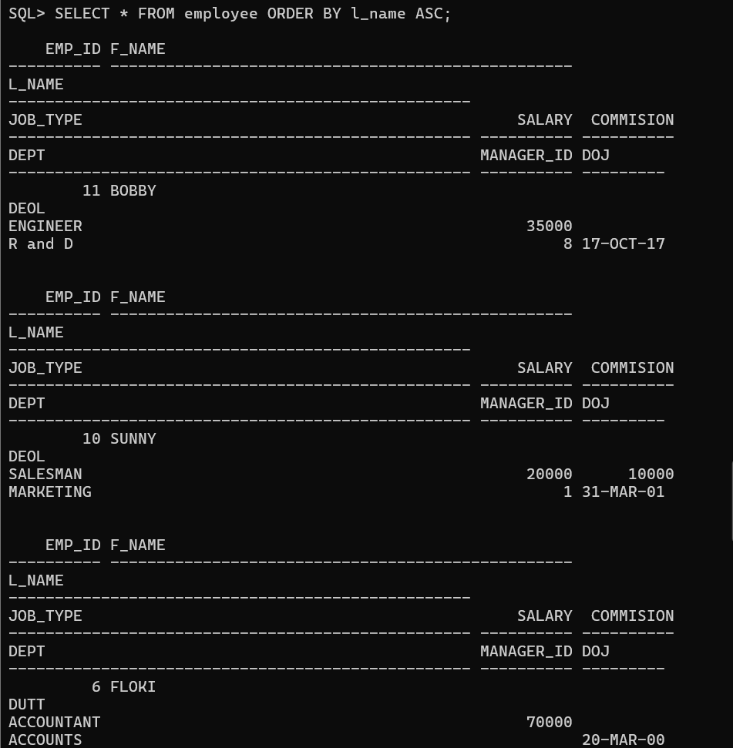

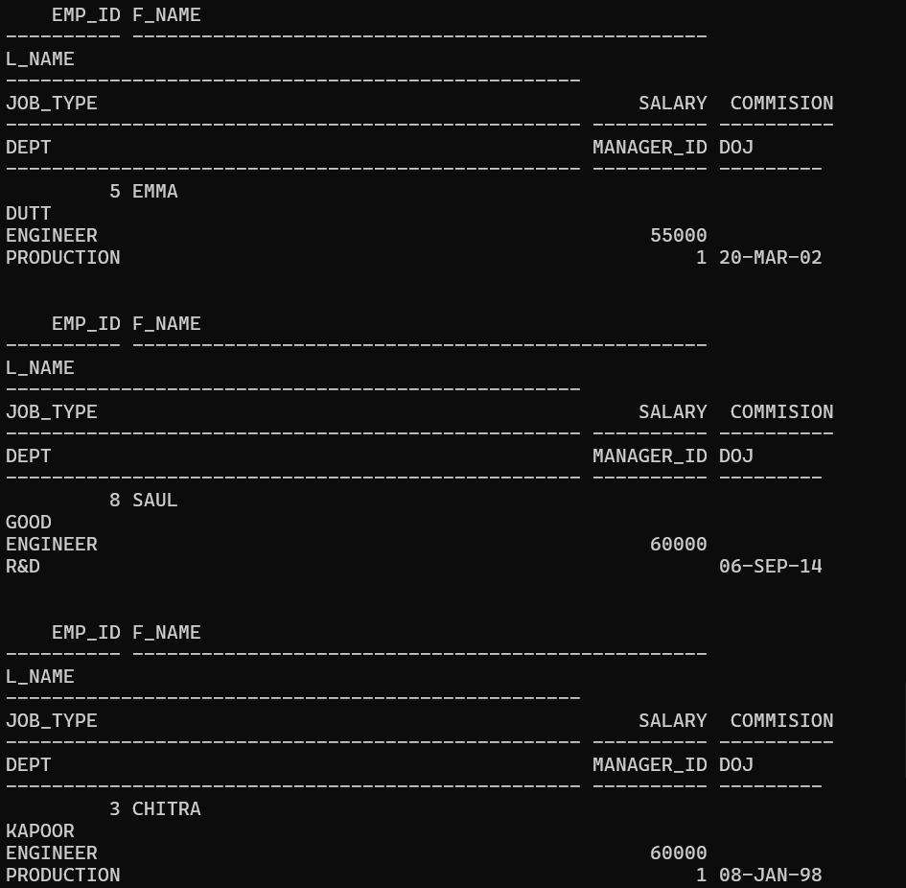

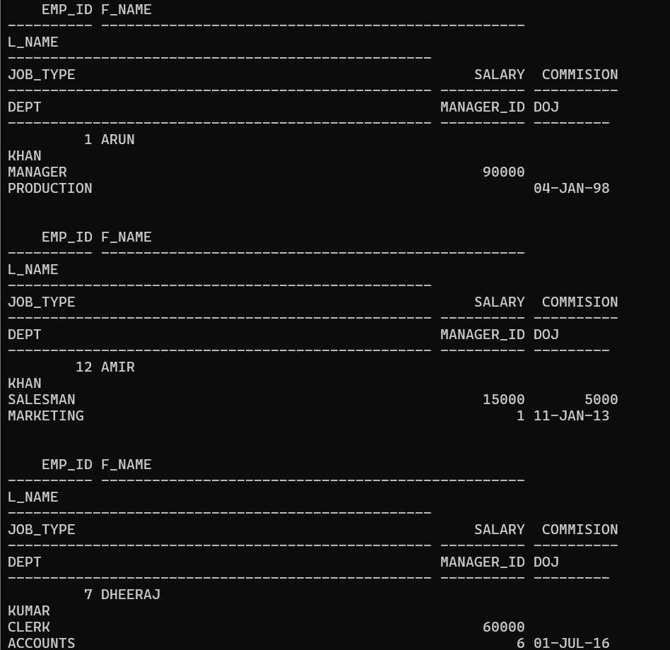

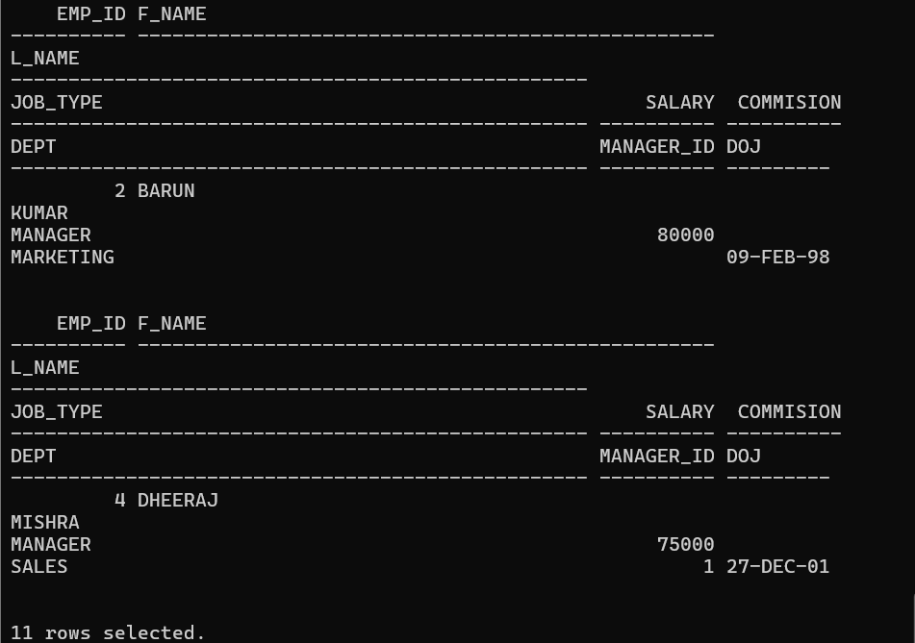

**Q57. Delete the employees who are working as salesmen and having less experience than 15 years.**

**Q58. Commit the database.**

